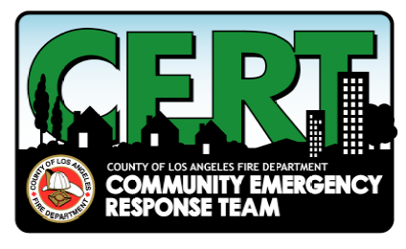 | Community Emergency Response Team  Training class starting  Saturday, October 25, 2014
C.E.R.T. TRAINING IS COMING TO Gardena—ENROLL NOW!

The County of Los Angeles Fire Department is proud to present this training to the public.

Following a major disaster, police, fire and medical professionals may not be able to fully meet the demand. People will have to rely on each other to meet the immediate life saving and life sustaining needs, particularly in isolated neighborhoods that may be cut off from the main roads for a period of time.

The County of Los Angeles Fire Department’s Community Emergency Response Team (C.E.R.T.) program was developed to provide basic training in safety and life saving skills for the general public.

The course curriculum covers the following modules:

October 25, 2014 | November 1, 2014 | November 8, 2014
Disaster Preparedness  Disaster Operations 1  Fire Suppression | Disaster Medical  Operations 2  Light Search & Rescue | Terrorism  Disaster Psychology  Team Organization  Review/Simulation

The training course will be presented as a series of *three (3) Saturday classes. Scheduled class dates are:

Saturday, October 25th, November 1st and November 8th, 2014
9:00 .am.- 4:30 p.m.
Gardena Transit Administration Building
13999 S. Western Avenue, Gardena, Ca 90247

C.E.R.T. training is free of charge

To enroll, contact:
Cindy Matsuda, Tri-City CERT Vice President
Phone: (310) 528-8730
Email: hopecindymatsuda@gmail.com

*Students must complete all 20 hours of the course to receive a certificate of completion. If you must

miss any units, you can make them up anywhere CERT is taught to receive your certificate.

