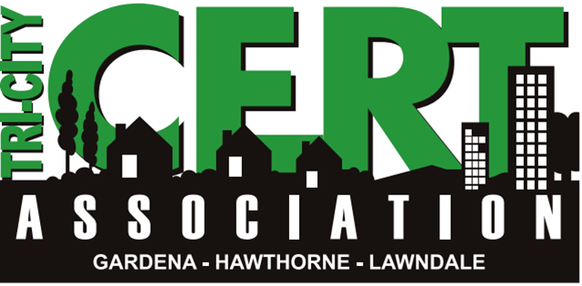
TRI-City CERT (Community Emergency Response Team) for the cities of Gardena, Hawthorne & Lawndale Meeting
This meeting is open to the Community as well as ALL CERT members.
REVIEW BASIC CERT PRINCIPLES-PART II
Come join us as we continue to review basic CERT principles. We will cover Disaster Medical Operations 1 & 2; Disaster Psychology, CERT Organization and Chain of Command. We are reviewing these modules in preparation for the Joint South Bay CERT Shakeout Drill on October 17th and to refresh our knowledge of CERT basic principles. Register for Area G Joint CERT Shakeout Drill by October 3 at www.mbcerta.org/shakeout
Speaker: Jose Hernandez, President

Thursday, October 1, 2015 from 6:30-9:00 P.M.
6:30-7:00 P.M. CERT Social time-Meet the speaker and other CERT members over refreshments.
7:00-9:00 P.M. Guest Speaker (Please note we will START ON TIME)
Gardena Valley Baptist Church
1630 West 158th Street (between Denker Ave and 158th St.) in Gardena
Room 201 (Enter through main doors on 158th St./parking on street) IF DOORS ARE LOCKED, CALL or TEXT CINDY MATSUDA AT 310-528-8730
SAVE THE DATE! SATURDAY,OCTOBER 17, 2015
JOINT AREA G (SOUTH BAY) CERT SHAKEOUT DRILL

This meeting is sponsored by Gardena Valley Baptist Church Disaster Preparedness Ministry and TRI-CITY CERT.ASSOCIATION. For more info, you may contact either Claudio Taniguchi, Training Coordinator at Office - 310. 349. 1687 or by email at ctaniguchi@cityofhawthorne.org or Cindy Matsuda, Vice President at hopecindymatsuda@gmail.com or call her at (310) 528-8730

